Curved Boundary
# Source: AI Source: Provided by: [Data Path: Persons Table -> ID Column: 1, Name_En Column: Motasem Essam] -> From: [ChatGPT] on [7/25/2026]
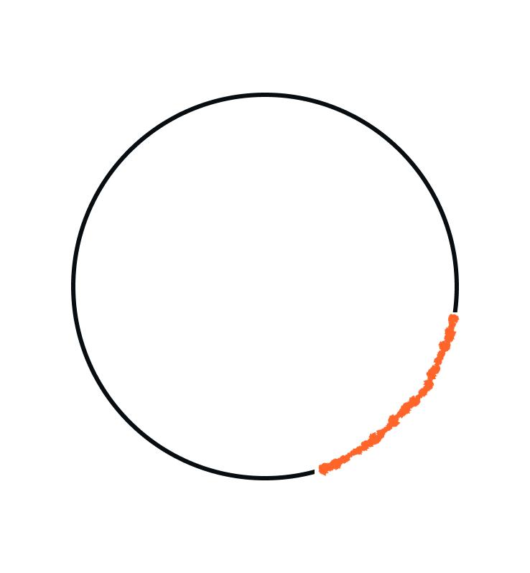
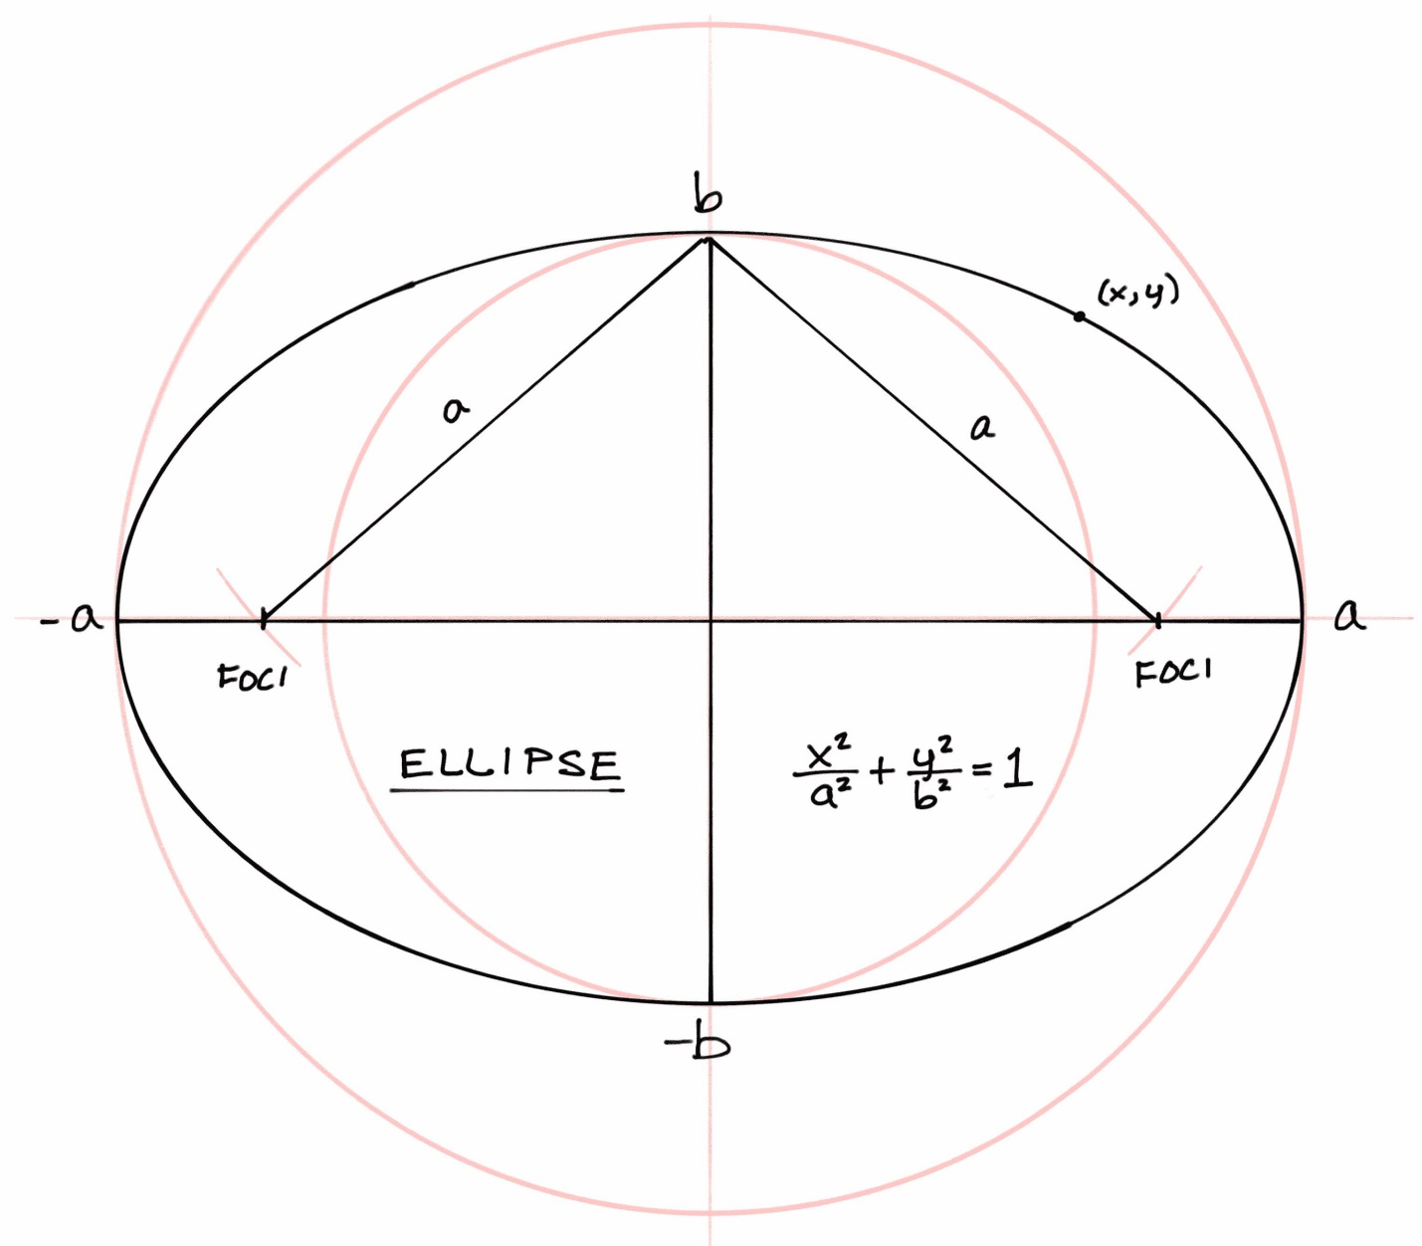
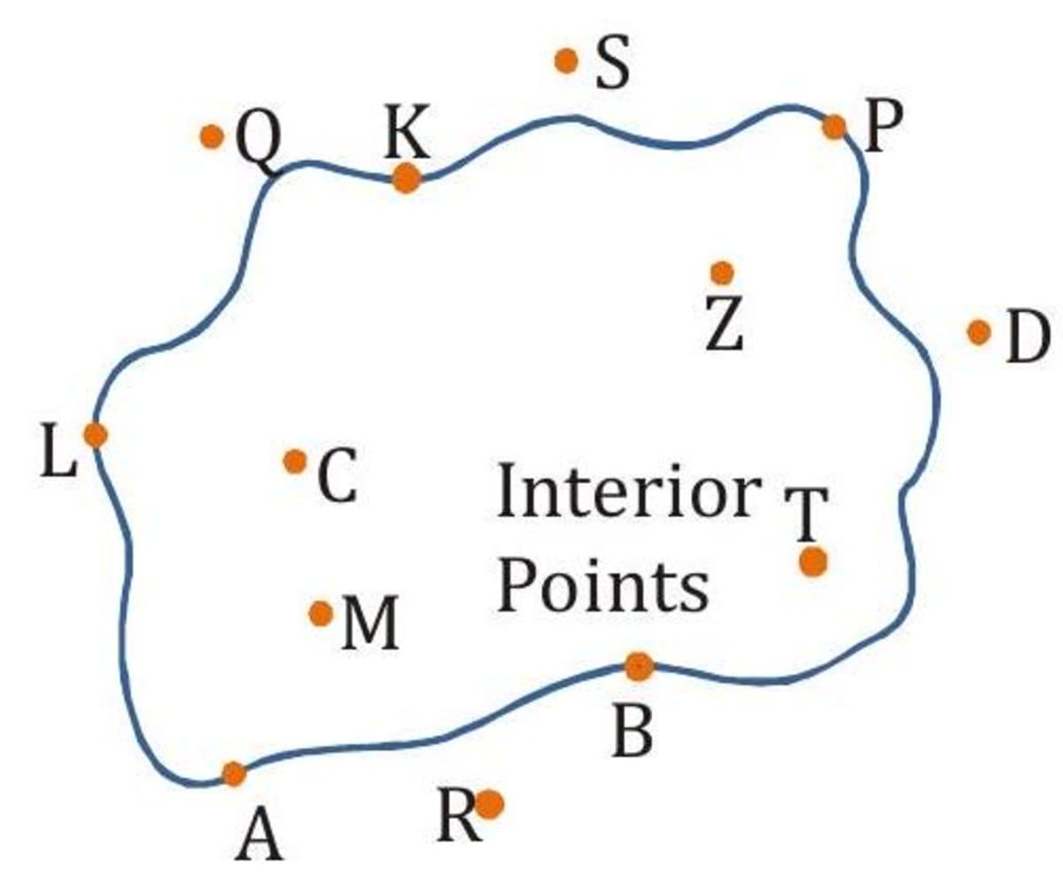
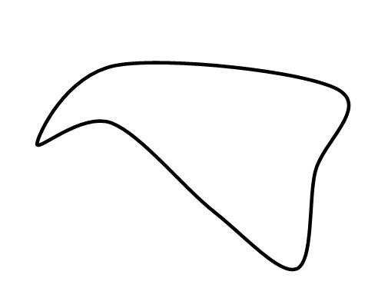

Definition
# Source: AI Source: Provided by: [Data Path: Persons Table -> ID Column: 1, Name_En Column: Motasem Essam] -> From: [ChatGPT] on [7/25/2026]
A Curved Boundary is a boundary formed entirely or primarily by one or more curves rather than straight line segments. It defines the edge or limit of a geometric figure using smooth, continuous curves.
A curved boundary may:
- Be closed, enclosing a region (such as a circle).
- Be open, with two distinct endpoints (such as an arc).

Characteristics
# Source: AI Source: Provided by: [Data Path: Persons Table -> ID Column: 1, Name_En Column: Motasem Essam] -> From: [ChatGPT] on [7/25/2026]
A curved boundary:
- Is composed of curves.
- Contains no straight edges (unless it is part of a mixed boundary).
- May be open or closed.
- Has length (curve length or arc length), but no thickness.
- May enclose a bounded region if it forms a closed loop.
- Contains infinitely many points.

Illustration

Closed Curved Boundary (Circle)
# Source: AI Source: Provided by: [Data Path: Persons Table -> ID Column: 1, Name_En Column: Motasem Essam] -> From: [ChatGPT] on [7/25/2026]
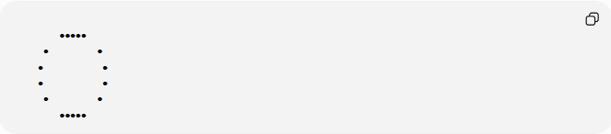
●●●●●
● ●
● ●
● ●
● ●
●●●●●
The circumference is a closed curved boundary.

Open Curved Boundary (Arc)
# Source: AI Source: Provided by: [Data Path: Persons Table -> ID Column: 1, Name_En Column: Motasem Essam] -> From: [ChatGPT] on [7/25/2026]
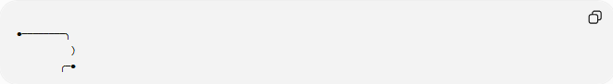
●────────╮
)
╭─●
The arc has two endpoints and is an open curved boundary.

Mathematical Representation
# Source: AI Source: Provided by: [Data Path: Persons Table -> ID Column: 1, Name_En Column: Motasem Essam] -> From: [ChatGPT] on [7/25/2026]
Curved boundaries are commonly represented using equations of curves.
Circle
$$x^{2}+y^{2}=r^{2}$$
The boundary is the circumference.

Ellipse
$$\frac{x^{2}}{a^{2}}+\frac{y^{2}}{b^{2}}=1$$
The ellipse itself forms the boundary.

Parabola
$$y=x^{2}$$
The curve represents an open curved boundary.

Examples
# Source: AI Source: Provided by: [Data Path: Persons Table -> ID Column: 1, Name_En Column: Motasem Essam] -> From: [ChatGPT] on [7/25/2026]
Example 1 – Circle
The circumference is a curved boundary enclosing a circular region.

Example 2 – Ellipse
The ellipse forms a closed curved boundary.

Example 3 – Arc
A portion of a circle forms an open curved boundary.

Example 4 – Parabola
A parabola is an open curved boundary that extends infinitely.

Properties
# Source: AI Source: Provided by: [Data Path: Persons Table -> ID Column: 1, Name_En Column: Motasem Essam] -> From: [ChatGPT] on [7/25/2026]
1. Continuous Curve
A curved boundary changes direction smoothly.

2. May Be Open or Closed
Closed:
- Circle
- Ellipse
Open:
- Arc
- Parabola
- Hyperbola branch

3. May Enclose a Region
Only closed curved boundaries completely enclose regions.

4. Infinite Points
Every curved boundary consists of infinitely many points.

Curve Length
# Source: AI Source: Provided by: [Data Path: Persons Table -> ID Column: 1, Name_En Column: Motasem Essam] -> From: [ChatGPT] on [7/25/2026]
The length of a curved boundary is measured by:
- Arc length.
- Circumference.
- Curve length.
Examples:
Circle circumference:
$$C=2πr$$

Real-World Examples
# Source: AI Source: Provided by: [Data Path: Persons Table -> ID Column: 1, Name_En Column: Motasem Essam] -> From: [ChatGPT] on [7/25/2026]
Curved boundaries include:
- Wheels.
- Coins.
- Plates.
- Stadium tracks.
- Domes.
- Arches.
- Circular gardens.
- Lakes.
- Roundabouts.

Applications
# Source: AI Source: Provided by: [Data Path: Persons Table -> ID Column: 1, Name_En Column: Motasem Essam] -> From: [ChatGPT] on [7/25/2026]
Curved boundaries are used in:
- Plane Geometry
- Coordinate Geometry
- Analytic Geometry
- Differential Geometry
- Engineering
- Architecture
- Mechanical Design
- CAD (Computer-Aided Design)
- Computer Graphics
- Industrial Design

Advantages
# Source: AI Source: Provided by: [Data Path: Persons Table -> ID Column: 1, Name_En Column: Motasem Essam] -> From: [ChatGPT] on [7/25/2026]
Studying curved boundaries helps to:
- Model natural shapes.
- Describe circular objects.
- Compute arc length.
- Analyze smooth curves.
- Design engineering components.

Limitations
# Source: AI Source: Provided by: [Data Path: Persons Table -> ID Column: 1, Name_En Column: Motasem Essam] -> From: [ChatGPT] on [7/25/2026]
A curved boundary:
- Is more difficult to analyze than straight boundaries.
- May require calculus for length calculations.
- Often involves nonlinear equations.

Comparison with Other Boundary Types
# Source: AI Source: Provided by: [Data Path: Persons Table -> ID Column: 1, Name_En Column: Motasem Essam] -> From: [ChatGPT] on [7/25/2026]
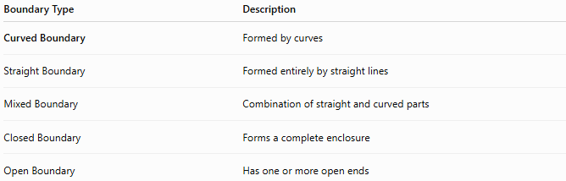
Boundary Type | Description
Curved Boundary | Formed by curves
Straight Boundary | Formed entirely by straight lines
Mixed Boundary | Combination of straight and curved parts
Closed Boundary | Forms a complete enclosure
Open Boundary | Has one or more open ends

Key Points
# Source: AI Source: Provided by: [Data Path: Persons Table -> ID Column: 1, Name_En Column: Motasem Essam] -> From: [ChatGPT] on [7/25/2026]
- A Curved Boundary is formed by one or more curves.
- It may be:
  - Open.
  - Closed.
- Examples include:
  - Circles.
  - Ellipses.
  - Arcs.
  - Parabolas.
- Closed curved boundaries can enclose bounded regions.

Conclusion
# Source: AI Source: Provided by: [Data Path: Persons Table -> ID Column: 1, Name_En Column: Motasem Essam] -> From: [ChatGPT] on [7/25/2026]
A Curved Boundary is a boundary defined by smooth curves instead of straight line segments. It may be open or closed and is commonly found in figures such as circles, ellipses, arcs, and parabolas. Curved boundaries are fundamental in plane geometry, coordinate geometry, analytic geometry, differential geometry, engineering, architecture, CAD, industrial design, and computer graphics, where they are used to model natural forms, curved structures, and objects with smooth geometric shapes.

